

Practices for Secure Software Report

Table of Contents
Document Revision History 3
Client 3
Instructions 3
Developer 4
1. Algorithm Cipher 4
2. Certificate Generation 4
3. Deploy Cipher 4
4. Secure Communications 4
5. Secondary Testing 4
6. Functional Testing 4
7. Summary 4
8. Industry Standard Best Practices 4

Document Revision History

Version | Date | Author | Comments
1.0 | 06/19/26 | Robert Cardoza | Completed secure communications implementation, checksum verification, dependency testing, and security analysis.

Client



Developer
Robert Cardoza

Algorithm Cipher

For this project, the SHA-256 hashing algorithm was implemented to generate a checksum value for data verification. SHA-256 is a cryptographic hash function that produces a unique 256-bit hash value for a given input. The algorithm helps ensure data integrity because even a small modification to the original data results in a completely different hash value. This makes SHA-256 useful for verifying that information has not been altered during storage or transmission. The generated checksum was displayed through the application and used to demonstrate secure verification of data.

Certificate Generation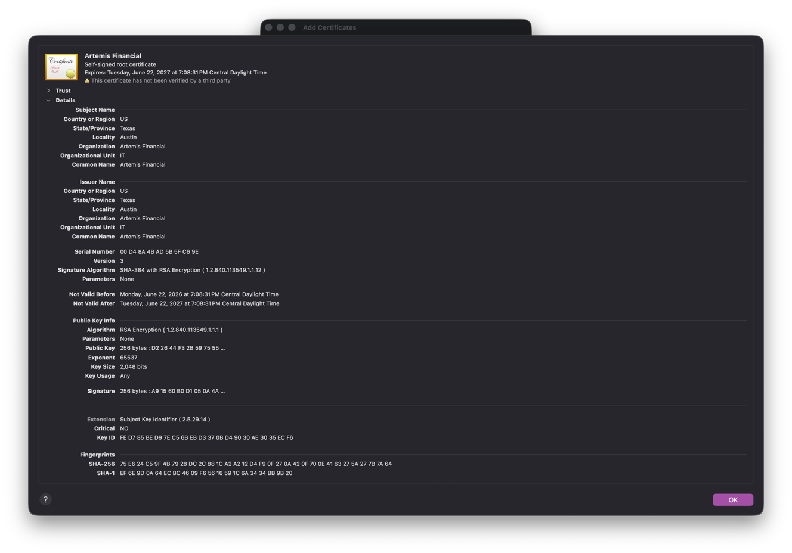

Deploy Cipher
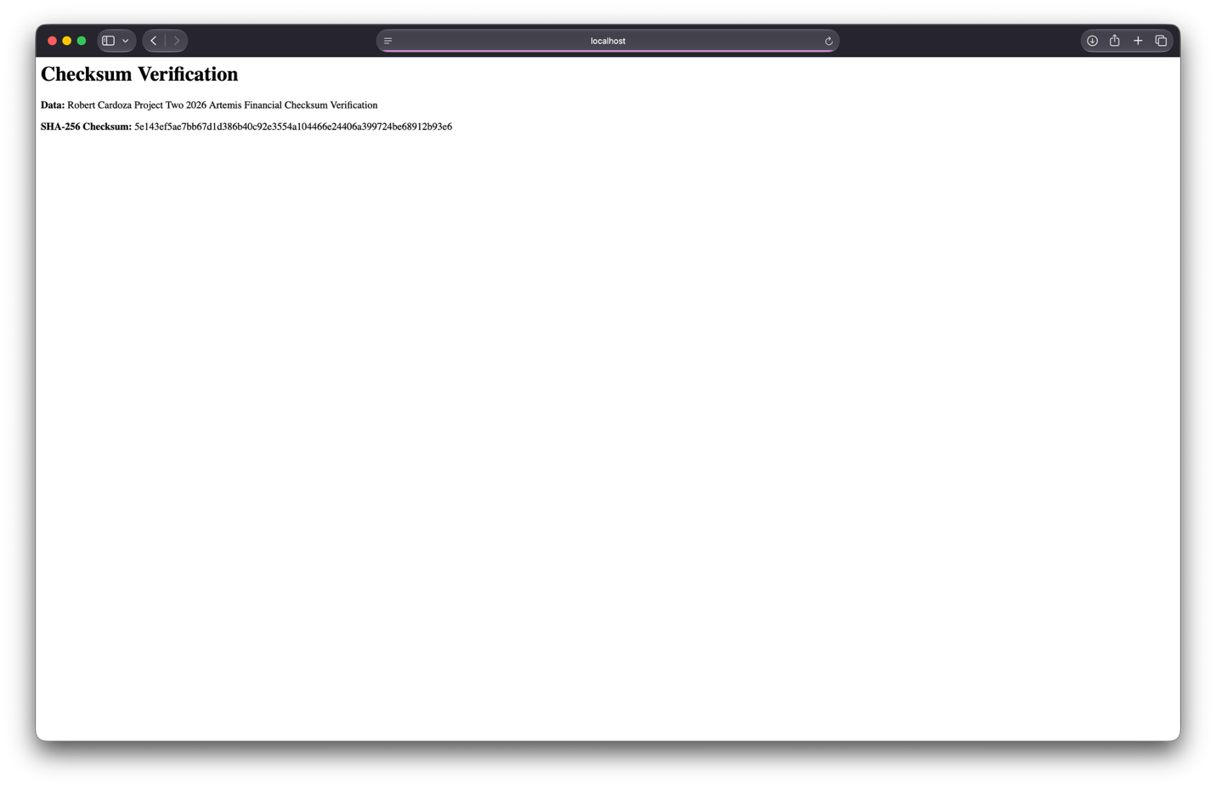

Secure Communications 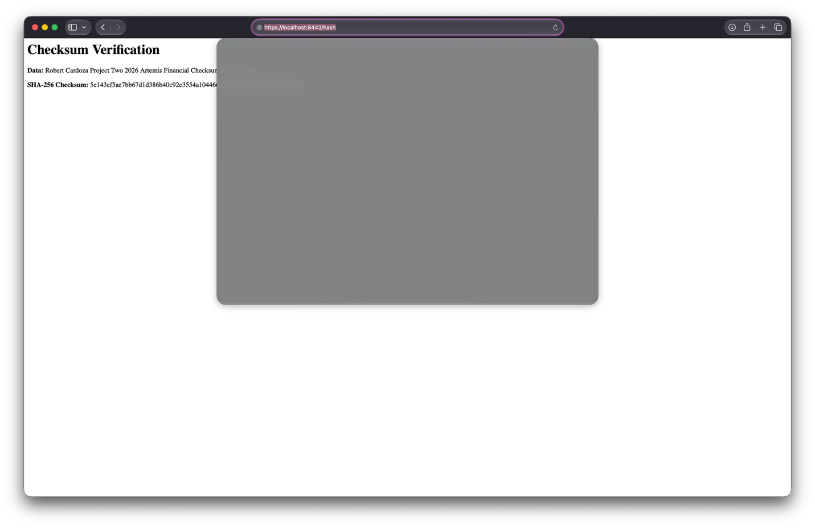

Secondary Testing
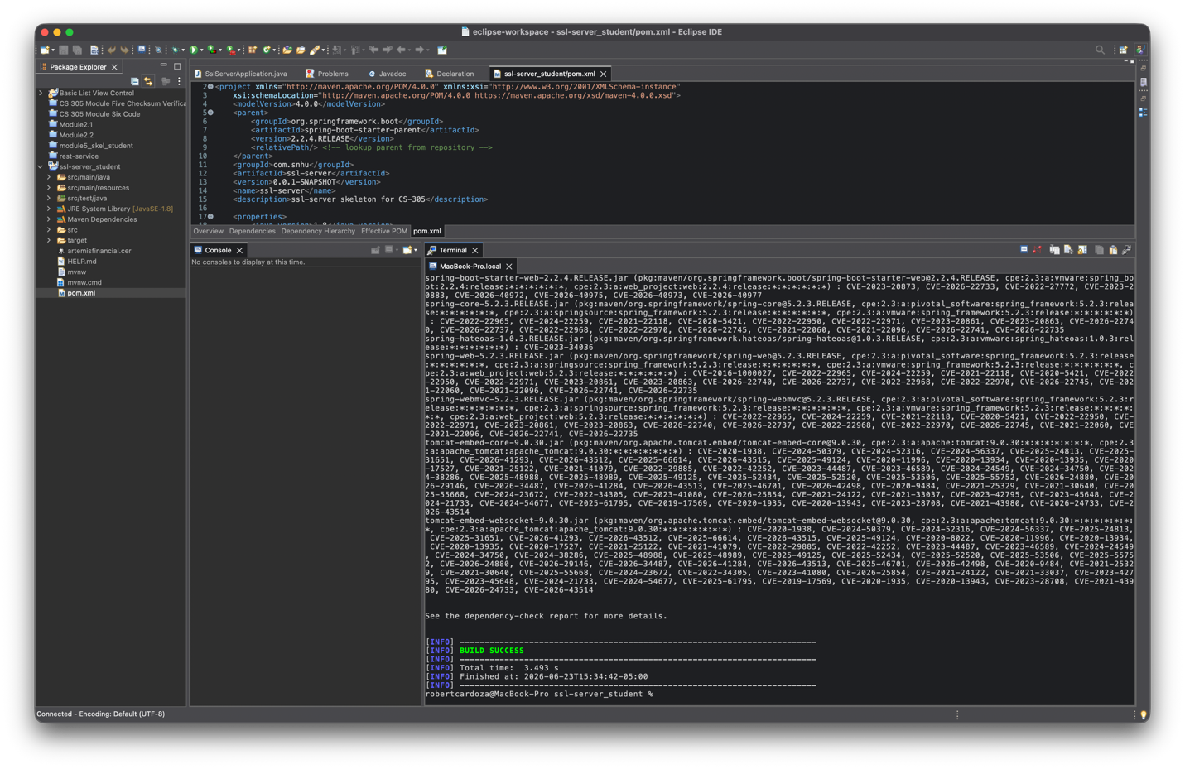
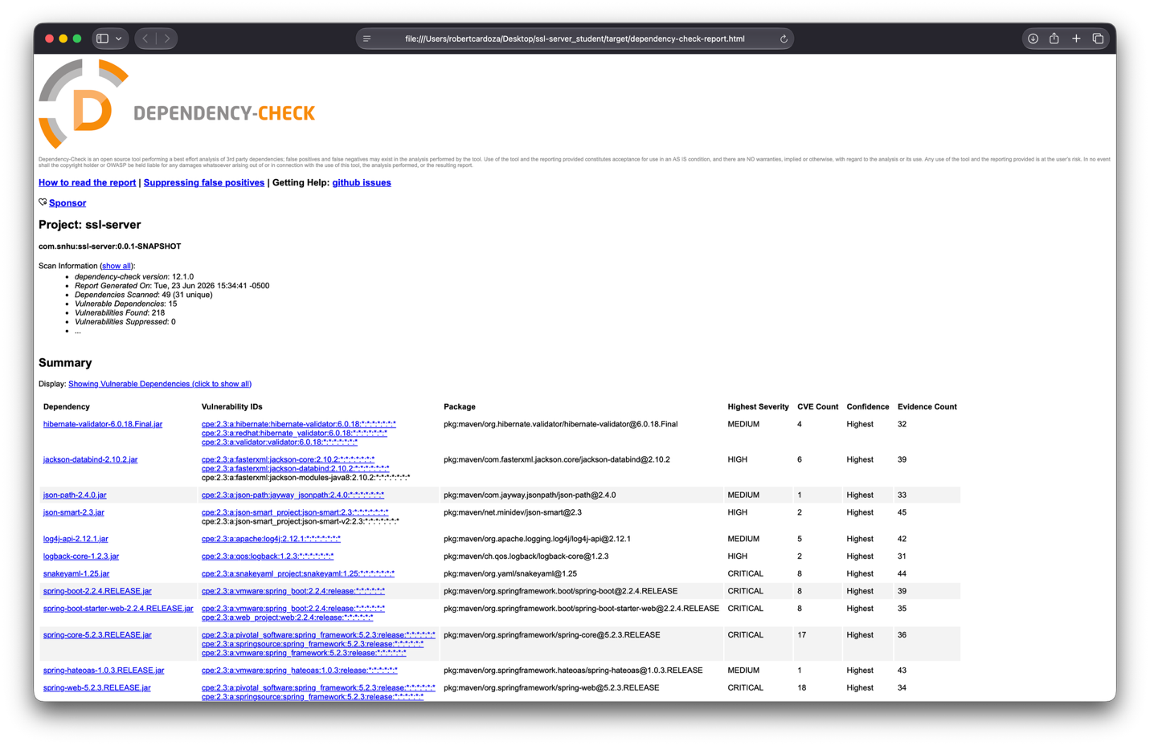

Functional Testing
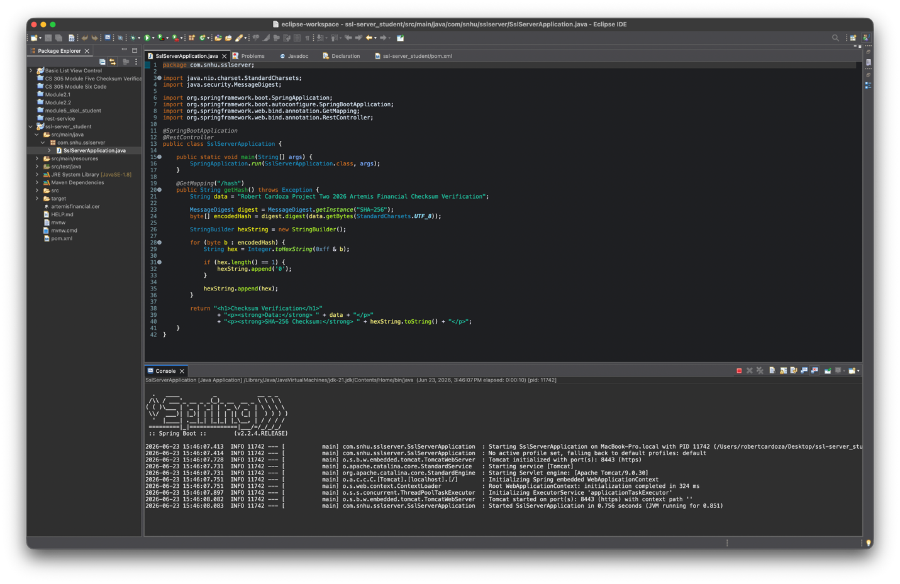

Summary

The Artemis Financial application was refactored to add additional layers of security for secure communication and data verification. Following the vulnerability assessment process, the main areas addressed were secure communications, cryptographic hashing, certificate-based encryption, dependency scanning, and functional testing. HTTPS was enabled by generating a self-signed certificate with Java Keytool, exporting the certificate as a CER file, and configuring the application properties file to use SSL on port 8443. A SHA-256 checksum endpoint was also added to verify data integrity and demonstrate that transmitted data could be checked for unauthorized modification.
The process of adding security layers included first generating and configuring the certificate, then refactoring the application code to implement the checksum, then testing the application in a browser using HTTPS, and finally running OWASP Dependency-Check as a secondary static testing tool. These steps helped confirm that the refactored code executed successfully and that no additional vulnerabilities were introduced by the checksum functionality that was added during refactoring. Although the dependency-check report identified vulnerabilities in existing project dependencies, the added refactored code relied on built-in Java security functionality and did not add new vulnerable libraries.

Industry Standard Best Practices

Industry-standard secure coding practices were applied by using established cryptographic functionality, enabling HTTPS, reviewing the code manually, and scanning dependencies with OWASP Dependency-Check. SHA-256 was selected because it is a widely used cryptographic hash algorithm for generating fixed-length checksum values. Java’s built-in MessageDigest class was used instead of a custom hashing method, which helped reduce the risk of implementation mistakes. HTTPS was configured to protect communication between the client and server, and the self-signed certificate demonstrated how certificate-based encryption can be used during development and testing.
Applying secure coding best practices helps protect Artemis Financial’s customers, business operations, and reputation. Because the company handles financial planning information, confidentiality and data integrity are especially important. Secure coding reduces the chance of unauthorized access, tampering, and data exposure. It also supports the company’s long-term well-being by making the application easier to test, maintain, and improve over time. Using security tools and secure development practices supports the idea that security is everyone’s responsibility and helps ensure that software is built with protection in mind from the beginning.

